I will show you the following two ways of taking a backup of an existing database:

1. Using a SQL Query
2. Using the Object Explorer

**Taking Backup Using Object Explorer**

Let us try the first technique now. Open SQL Server and login using valid credentials.  
  
**Step 1**

Right-click on the database. Go to Tasks -> Back Up.  
  
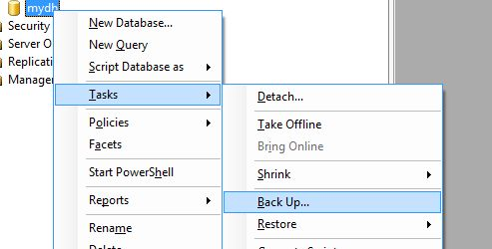  
  
**Step 2**

Click on Add.  
  
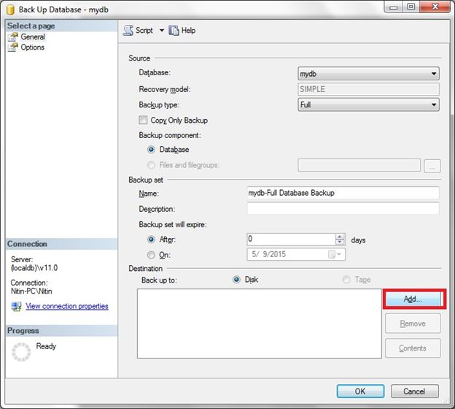  
  
**Step 3**

Provide a valid path and name to the database. Append “.bkp” to the file name. Click OK.  
  
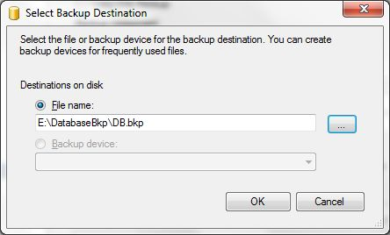  
  
**Step 4**

Click OK.  
  
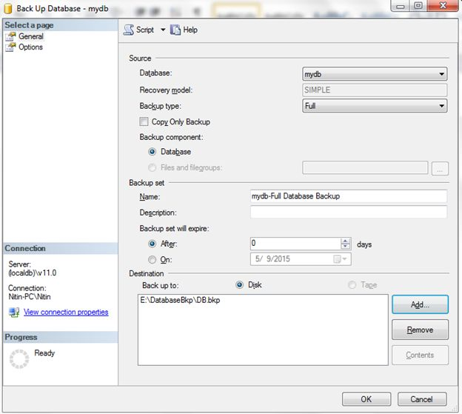  
  
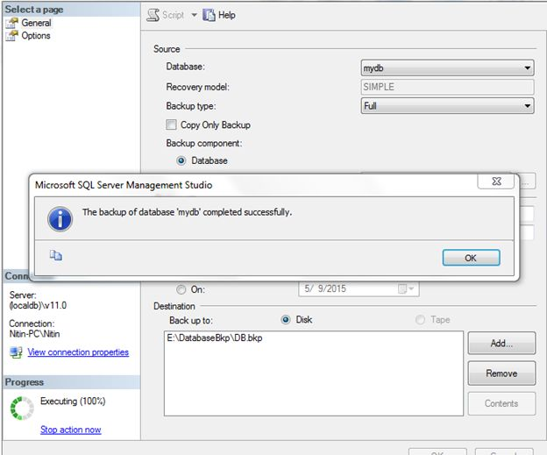  
  
We get the backup of the database in the desired location.  
  
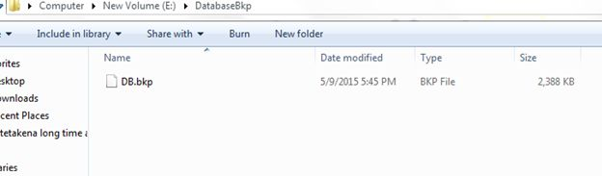  
  
**Taking Backup Using SQL Query**  
  
Execute the following SQL query:

*BACKUP DATABASE mydb TO DISK = 'E:\DatabaseBkp\DB2.bak'*

Execute the query.  
  
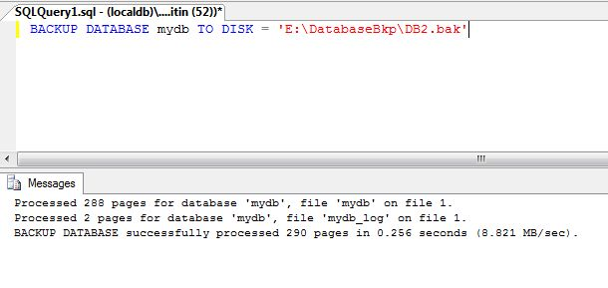  
  
We will get the following message. Let us now check the folder.  
  
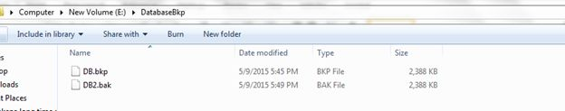  
  
As we can see, we have a new database in the folder. This is how we take a backup of a SQL Server database.